Lab Deliverable 2 Implementing OOP concepts in C#

Part II

- Write a program to display the name and age of a person. Use a default constructor to assign values to the name and age variables. Use a parameterized constructor to pass the values of name and age. Use a single method to display the values from both the constructors.

Solution:

using System;

class Employee
{
private string name;
private int age;

// Default Constructor
public Employee()
{
name="Mark";
age=25;
}

// Parameterized Constructor
public Employee (string varName, int varAge)
{
name = varName;
age = varAge;
}

public void ShowData()
{
Console.WriteLine("Name = " + name);
Console.WriteLine("Age = " + age);
}

static void Main()
{
Employee objEmpOne = new Employee ();
Employee objEmpTwo = new Employee ("Allen",30);
objEmpOne.ShowData();
Console.WriteLine();
objEmpTwo.ShowData();
}
}

The output of the program is as shown in Figure 2.1.

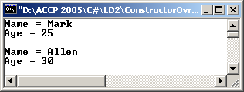

Figure 2.1: Output of Employee.cs

- Write a program that calculates the square of an integer, say 3 and a double, say 4.2. Use method overloading to calculate the square of the integer and double values.

Solution:

using System;
class Maths
{
public void DoOverLoad()
{
int intX = 3;
double dblY = 4.2;
Console.WriteLine("Square of int value is : "+Square(intX) + "\n" + "Square of double value is : " + Square(dblY));
}

public int Square(int intY)
{
return intY*intY;
}

public double Square(double dblY)
{
return dblY*dblY;
}
}

public class OverLoad
{
public static void Main()
{
Maths objMaths = new Maths();
objMaths.DoOverLoad();
}
}

The output of the program is as shown in the Figure 2.2.

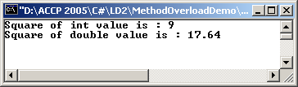

Figure 2.2: Output of Maths.cs

- Write a program that displays the values of two integers; intX and intY. Assign the values 10 and 20 to intX and intY respectively using a parameterized constructor. Include a default constructor that does nothing. Instantiate an object of this constructor and print the values of the variables intX and intY. Overload the operator – to change the sign of the values (i.e. negative values). Display the values of intX and intY.

Solution:

using System;

class Complex
{
private int intX;
private int intY;

public Complex()
{
}
public Complex(int intI, int intJ)
{
intX = intI;
intY = intJ;
}

public void showXY()
{
Console.WriteLine("X = "+intX+" ; Y = "+intY);
}

public static Complex operator -(Complex comC)
{
Complex objCom = new Complex();
objCom.intX = -comC.intX;
objCom.intY = -comC.intY;
return objCom;
}
}

class MyClient
{
public static void Main()
{
Complex objComOne = new Complex(10,20);
objComOne.showXY();
Complex objComTwo = new Complex();
objComTwo.showXY();
objComTwo = -objComOne;
objComTwo.showXY();
}
}

The output of the program is as shown in the Figure 2.3.

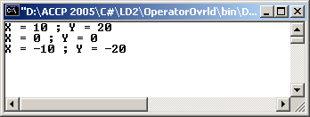

Figure 2.3: Output of Complex.cs

Do It Yourself

- Write a program to demonstrate Inheritance. Define a base class Vehicle having properties like type, color, speed, brand and methods Run() and Display(). The Run() method should display a message “I am running” and the type of the vehicle. The Display() method should display the various properties of the vehicle. Derive a class Car and initialized the derived attributes of base class Vehicle. Finally, in the Main() method execute Run() and Display()using an object of the derived class Car.

Solution:

using System;

class Vehicle
{
public string strType;
public string strColor;
public double dblSpeed;
public string strBrand;
public void Run()
{
Console.WriteLine(strType + " : I am running");
}
public void Display()
{
Console.WriteLine("Type : " + strType);
Console.WriteLine("Color : " + strColor);
Console.WriteLine("Speed : " + dblSpeed);
Console.WriteLine("Brand : " + strBrand);
}
}

class Car : Vehicle
{
public Car(Vehicle objVehicle)
{
strType = objVehicle.strType;
strColor = objVehicle.strColor;
dblSpeed = objVehicle.dblSpeed;
strBrand = objVehicle.strBrand;
}
}

class Inherit
{
static void Main()
{
Vehicle objVehicle = new Vehicle();
objVehicle.strType = "Car";
objVehicle.strColor = "Red";
objVehicle.dblSpeed = 100.2;
objVehicle.strBrand = "BMW";
Car objCar = new Car(objVehicle);
objCar.Run();
objCar.Display();
}
}

The output of the program is as shown in the Figure 2.4.

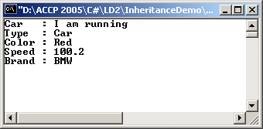

Figure 2.4: Output of Vehicle.cs

- Consider the previous question. Override the Run() method in the derived class to display a message “The CAR is running”.

Solution:

using System;

class Vehicle
{
public string strType;
public string strColor;
public double dblSpeed;
public string strBrand;

public virtual void Run()
{
Console.WriteLine(strType + " : I am running");
}
public void Display()
{
Console.WriteLine("Type : " + strType);
Console.WriteLine("Color : " + strColor);
Console.WriteLine("Speed : " + dblSpeed);
Console.WriteLine("Brand : " + strBrand);
}
}

class Car : Vehicle
{
public Car(Vehicle objVehicle)
{
strType = objVehicle.strType;
strColor = objVehicle.strColor;
dblSpeed = objVehicle.dblSpeed;
strBrand = objVehicle.strBrand;
}
public override void Run()
{
Console.WriteLine("The CAR is running");
}
}

class Inherit
{
static void Main()
{
Vehicle objVehicle = new Vehicle();
objVehicle.strType = "Car";
objVehicle.strColor = "Red";
objVehicle.dblSpeed = 100.2;
objVehicle.strBrand = "BMW";
Car objCar = new Car(objVehicle);
objCar.Run();
objCar.Display();
}
}

The output of the program is as shown in the Figure 2.5.

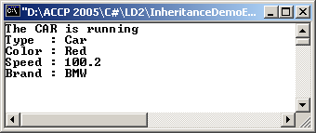

Figure 2.5: Output of Vehicle.cs

- Write a program to display the value of two integers using parameterized constructor and a method. Create two objects of this and pass the sets of values (10, 20) and (30, 40) respectively. Overload the ‘+’ operator to add the two x values and two y values of these objects to form a new object (x, y). The answer should be (10+30, 20+40) = (40, 60).

Solution:

using System;

class OperatorOvrldDemo
{
private int intX;
private int intY;

public OperatorOvrldDemo(int intI, int intJ)
{
intX = intI;
intY = intJ;
}

public void ShowXY()
{
Console.WriteLine(intX+" "+intY);
}

public static OperatorOvrldDemo operator +(OperatorOvrldDemo objCom1,OperatorOvrldDemo objCom2)
{
OperatorOvrldDemo objCom = new OperatorOvrldDemo();
objCom.intX = objCom1.intX+objCom2.intX;
objCom.intY = objCom1.intY+objCom2.intY;
return objCom;
}
}

class Addition
{
public static void Main()
{
OperatorOvrldDemo objCom1 = new OperatorOvrldDemo(10,20);
objCom1.ShowXY();
OperatorOvrldDemo objCom2 = new OperatorOvrldDemo(30,40);
objCom2.ShowXY();
OperatorOvrldDemo objCom3 = new OperatorOvrldDemo();
objCom3 = objCom1 + objCom2;
objCom3.ShowXY();
Console.ReadLine();
}
}

The output of the program is as shown in the Figure 2.6.

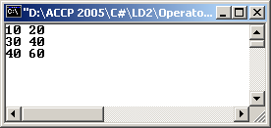

Figure 2.6: Output of OperatorOvrldDemo.cs

